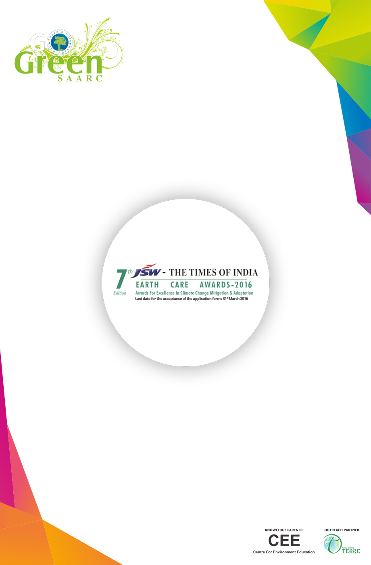

APPLICATION FORM
Category: Innovation for Climate Protection
PART - A: GENERAL INFORMATION

Name of Applicant:
Address

Phone Email
Location Office Contact Person
Sector
If you are applying as an individual, please enclose your detail resume
If applying as an organization; pl provide details on organization (Tick any one)
Private sector Public sector Other (Specify)
If you/ your organization have won any award/s related to Innovation in the past; please provide details.

PART B: TECHNICAL INFORMATION
Section I - Product/Service Information
1. Objective and context of innovation
2. Technical description (including quantitative and qualitative details) of the product/service
3. Provide development history – from conceptualization to current status

4. Please explain about innovation (product or service). Is this innovation a new technology or building upon an existing product or service
5. Provide details of other similar product available; what constraints or limitation is overcome by this innovation.
6. Please explain the key innovative aspects of product/service
Section II - Innovation - market applicability
7. What is the market potential - which segment and niche the innovation seeks to target. (Support with market survey or study figures)
Whether your product/service has reached the market? (Yes or No)
If yes, how long did it take to reach the market?
If no, how much time it will require to reach the market, or what is plan to introduce in market?
Section III - Standards and Certifications
8. What are the relevant standards and benchmark?Provide details

www.facebook.com/earth.care.awards www.earthcareawards.com

9. Performance of product/service with respect to standards.
10. Provide details on certification requirement with respect to product/service and compliance status with respect to certification. .
11. Is your product/ service subject to any regulatory approval/ requirement? Provide details.
Provide details on agencies recognized for certification and regulatory approval
12. Is your product/service patented?If yes, Please enclose patent document.

Section IV - Energy and Emission
13. How are the energy aspects addressed-provide information on reduction in energy use (kWh)?
14. ProvideGHG emission reduction figures
CO₂ emission reduction – One MWh reduction in energy use saves 0.82 t CO₂ (CEA, 2014)¹
15. Elaborate on environmental performance of product/service - does this lead to generation of any pollutant - CO, NOx, SOx, particulate matter, toxics
16. Provide details on toxicity and associated safety and health hazards. Elaborate on preventions and precautions

Section V - Financials
17. Project financing details
a. Self-Financing
b. Venture/Equity funds
c. Government/Institutional support
18. Sales data for the product/service (Last three years if applicable)
a. Product value and market share
19. Address financial viability of the innovation and the scale with respect to it
a. Return on Investment (ROI)

www.facebook.com/earth.care.awards www.earthcareawards.com

